## References

* Azure App Service: Web Apps   
  <https://azure.microsoft.com/zh-tw/services/app-service/web/>

## Requirements

* Azure Subscription
* Visual Studio

## Goals

* Publish the web application on internet through Azure App Service.

## Step 1: Provision a Web App on Azure

* Provision a Web App on Azure
  + Find **Web App** in Marketplace

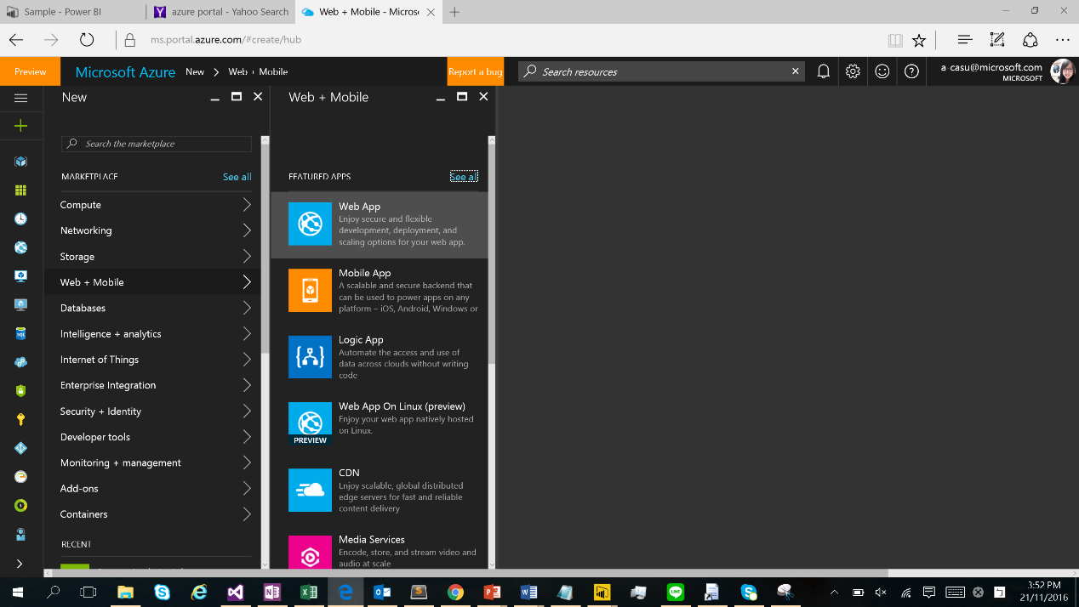

* + Configure the Web App setting
* Enter App Name
* Select Resource Group from existing
* Create New Service plan

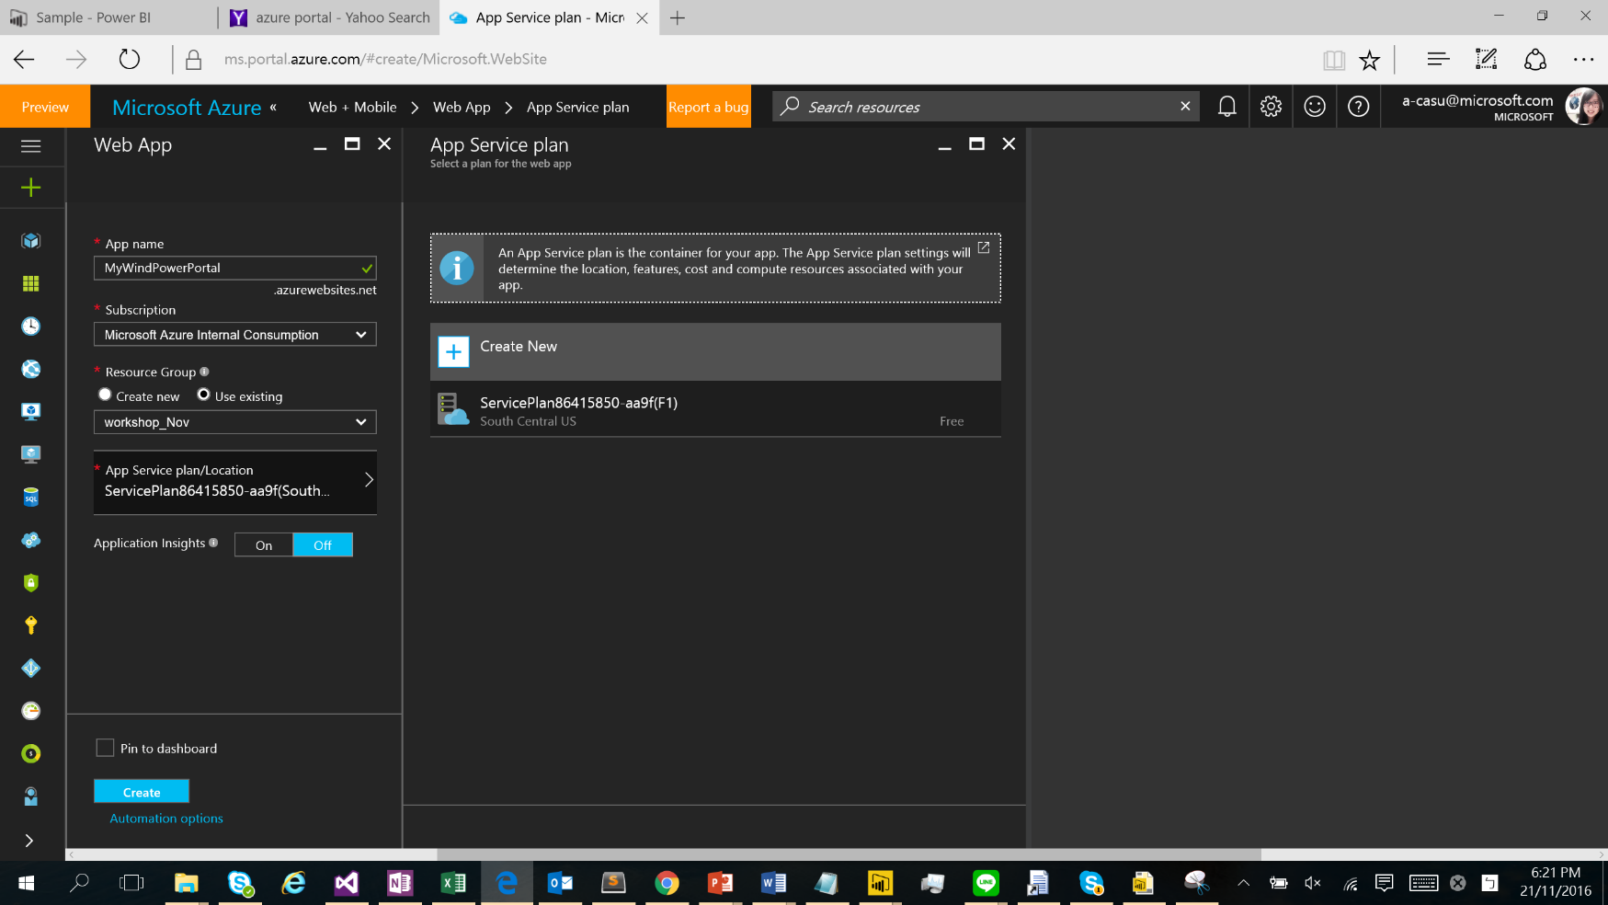

* + Add a **D1 shared** tier
    - Name your service plan
    - Select provisioned location in **East Asia**
    - Select the pricing tier as **D1 Shared**

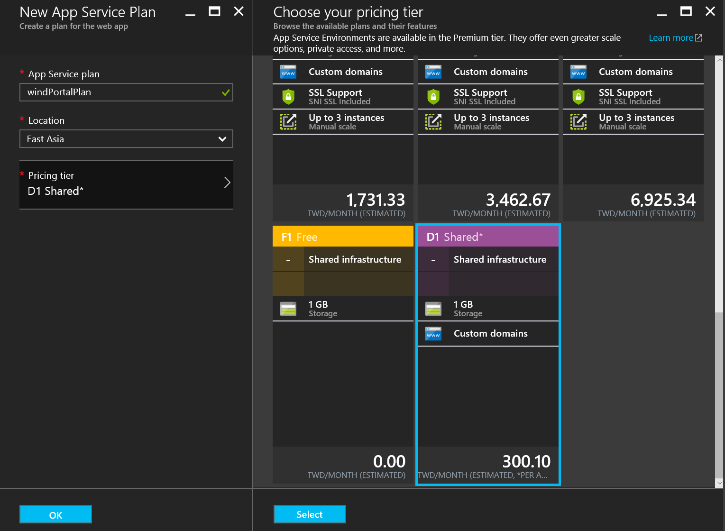

* + Select **OK >> Create** to deploy the web app
  + Take note for the Web App name

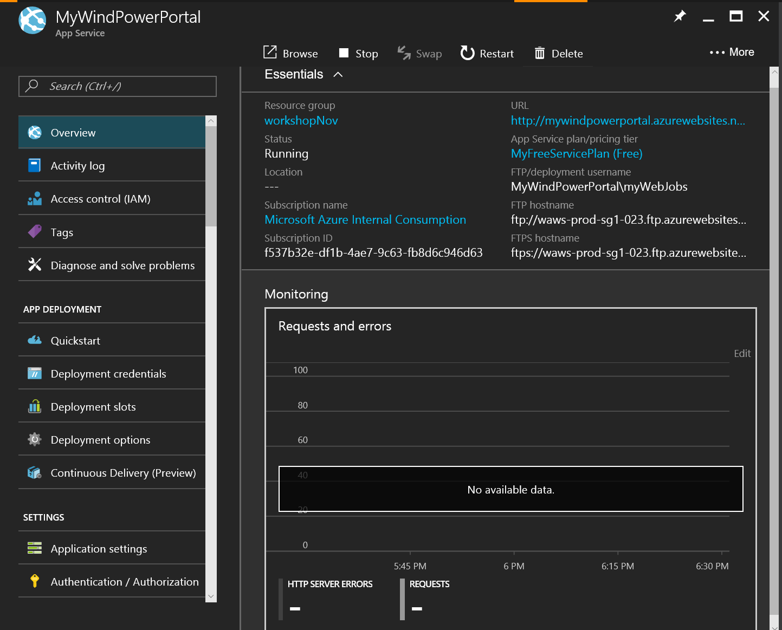

## Step 2: Publish the Power BI Web App Sample on Internet

* Publish **EmbedSample** project
  + Right click EmbedSample and select **Publish**

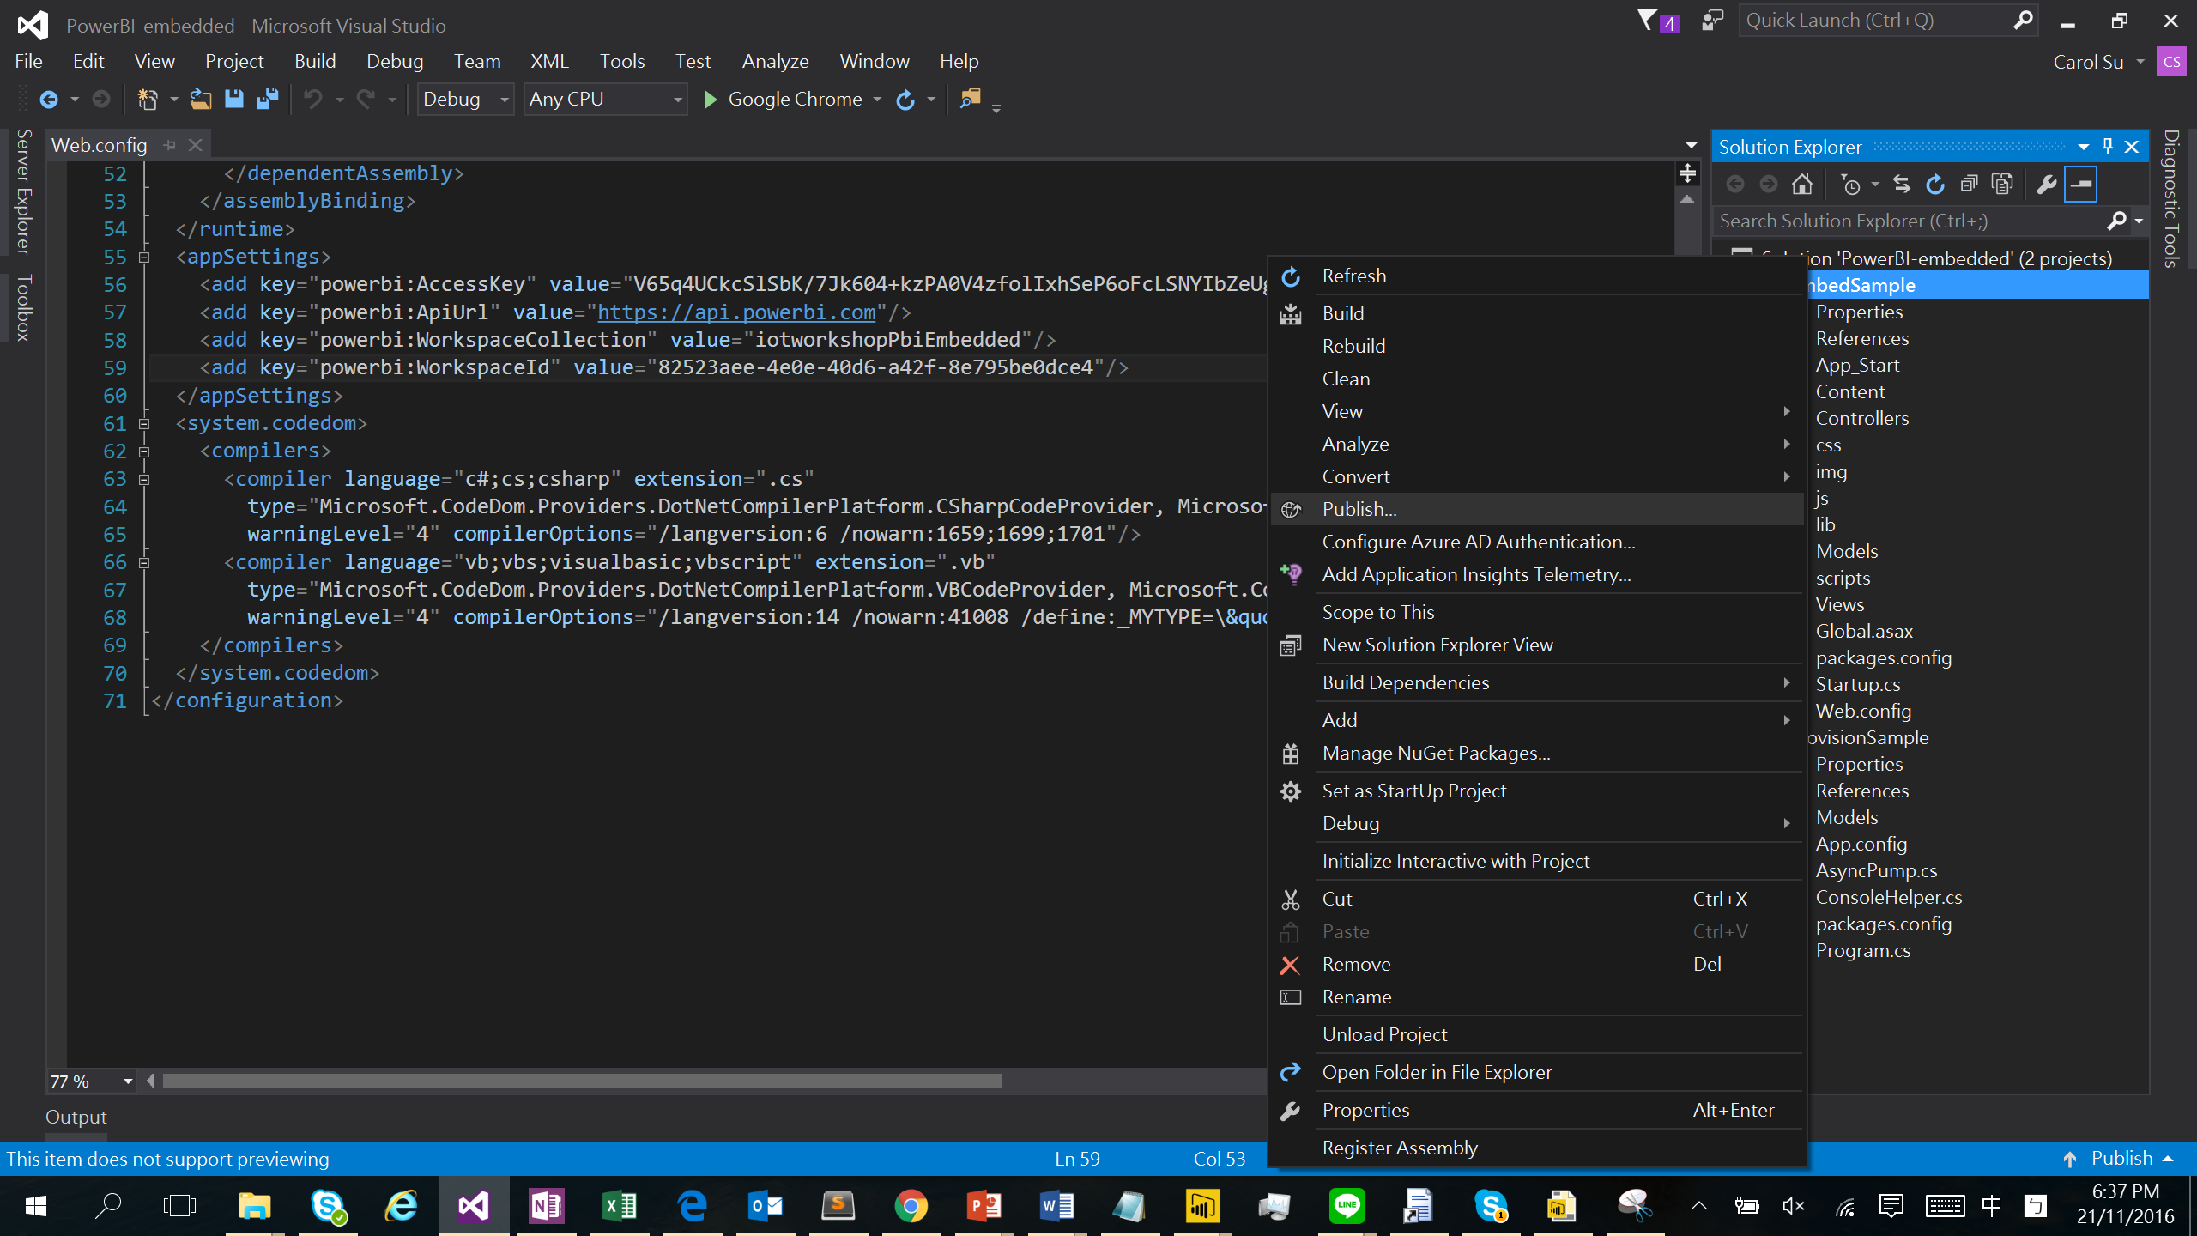

* + Select **Microsoft Azure App Service** as the publish target

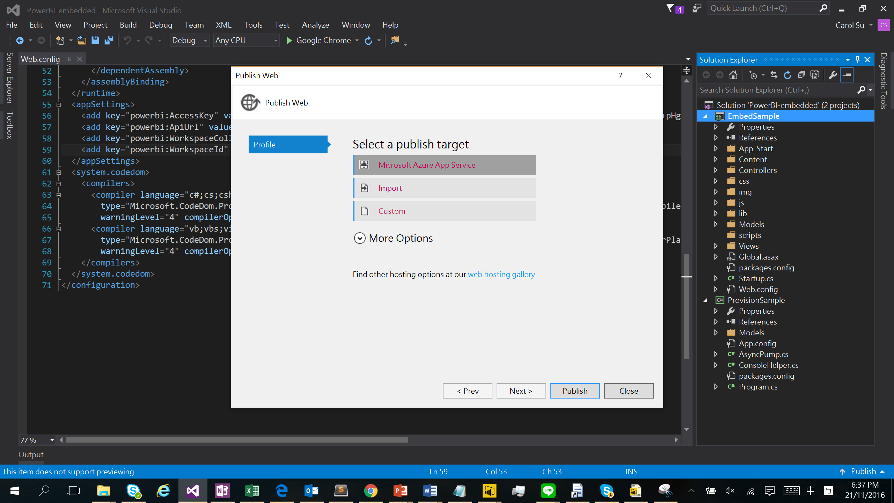

* + Openthe resource group that contains your web app
  + Select the web app

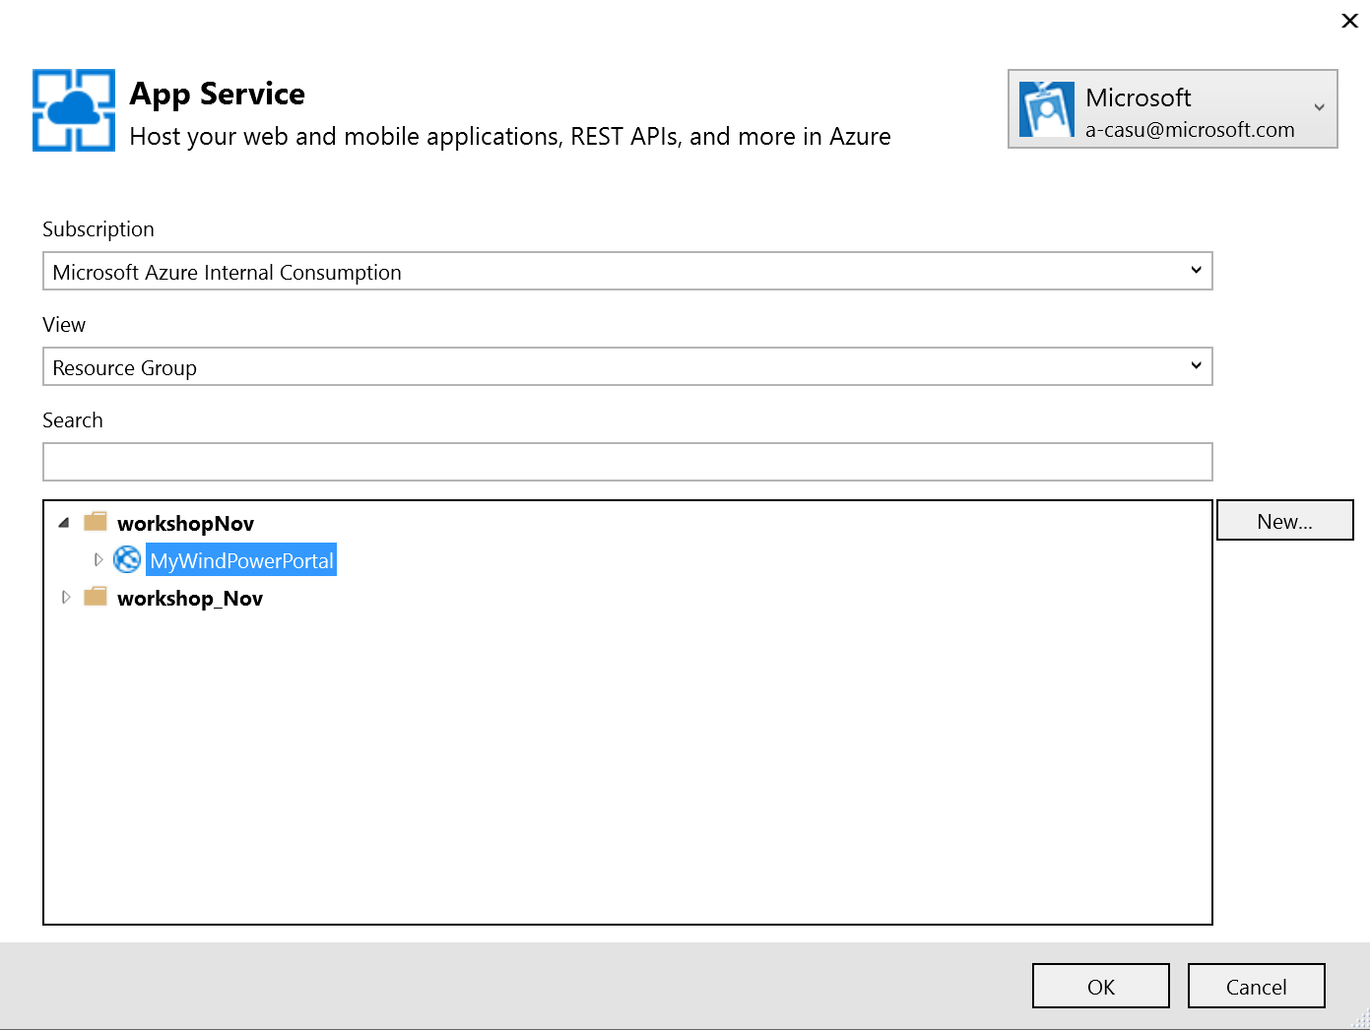

* + Select **Publish**

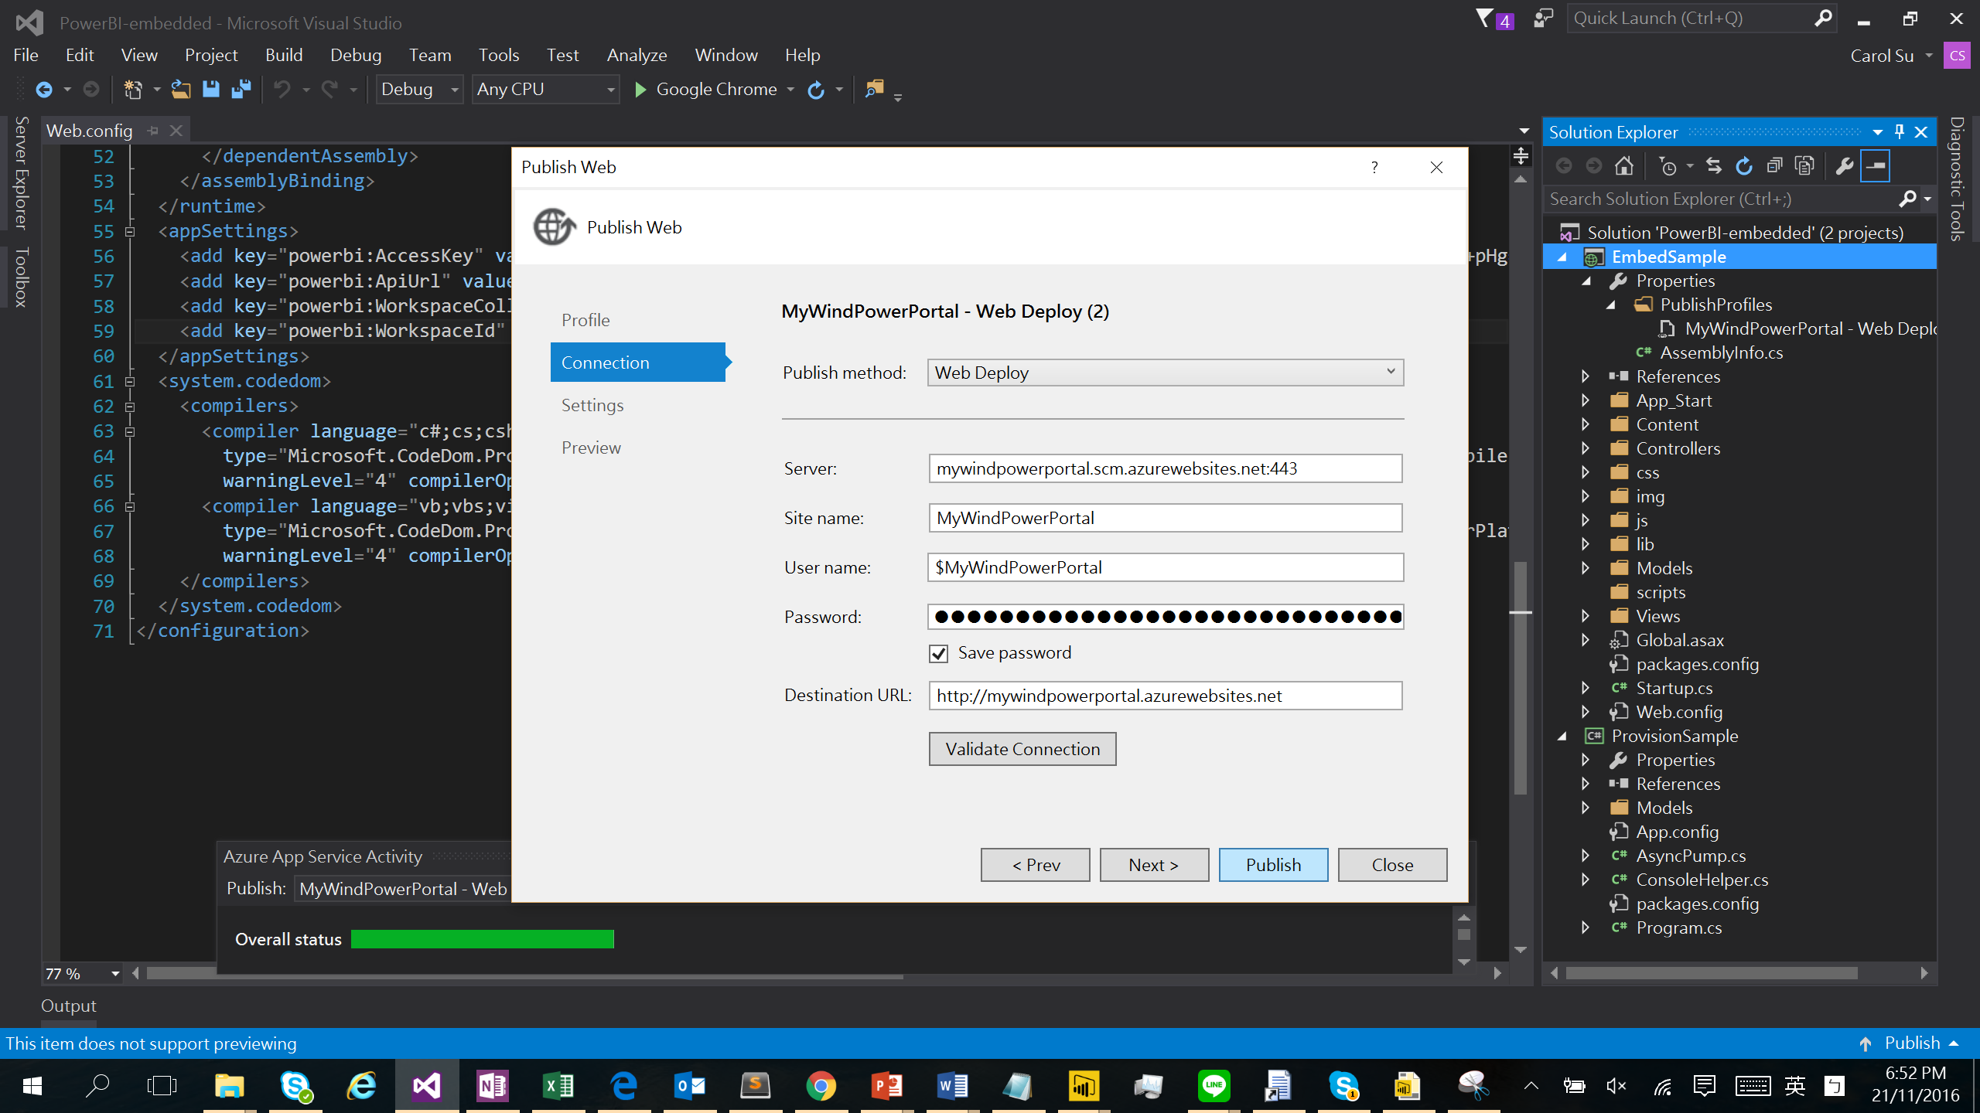

* + **EmbedSample** has been published onto Internet

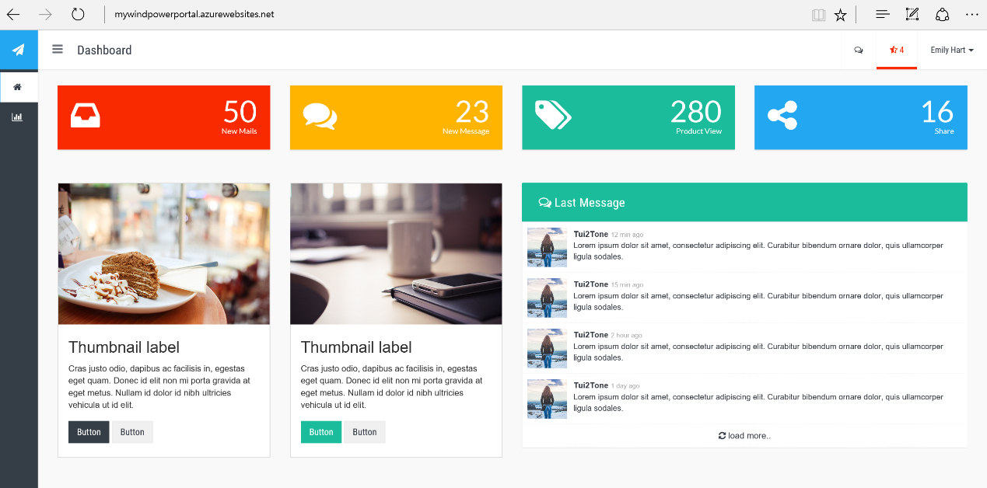

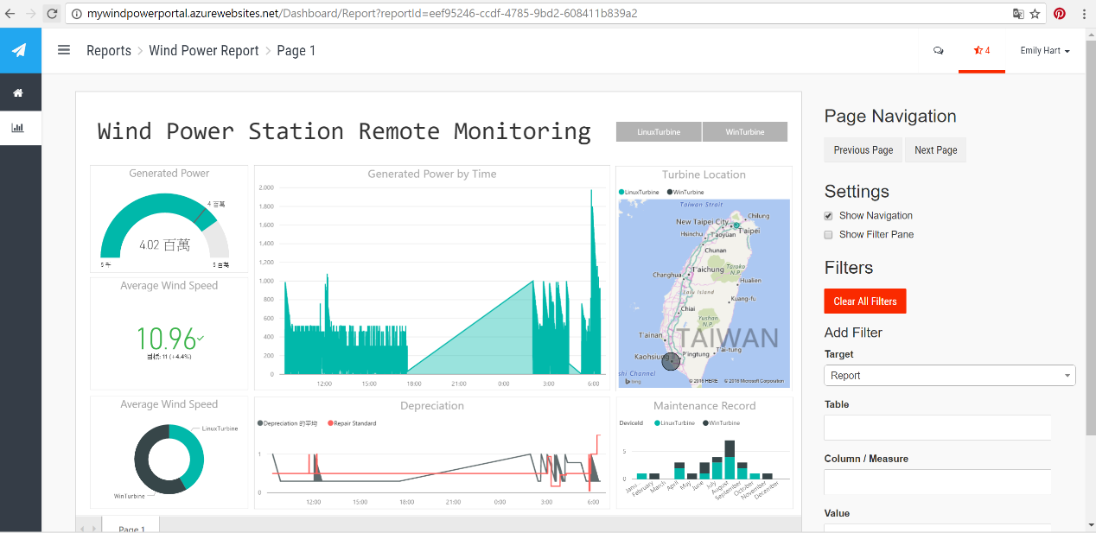

* *The HOL 8 has been completed. Now you have learned how to publish your web application through Azure App Service.*